55 Stonehaven Cr

2014

Chess Game

26510562

Contents

Introduction 2

Minimum System Requirements 2

Installation 2

Rules 2

Playing the Game 3

Special Features 5

Promotion 5

Castling 5

Saving Games 5

High Scores 5

Hints and Tips 6

Trouble Shooting Guide 6

Technical Support 7

# Introduction

Chess is an ancient two player board game that has its origins in India and quickly spread throughout the southern hemisphere. Players take turns to move pieces on a board and take their opponents king.

# Minimum System Requirements

Operating system: Windows 95

Programs installed: Microsoft Visual Studio 2010, Adobe Reader XI, Microsoft Word

Ram: 1 Gb

Storage: 500 Mb

# Installation

1. Turn your computer on
2. Import the “Chess Game” folder onto your computer
3. Open the folder and read, in full, the file called Chess Game v1.0.0 EULA.

By continuing to install the program, you agree to the terms and conditions of the EULA.

1. Double Click on the file called “Chess Game.exe”. The game should open automatically.

# Rules

The rules for the game are documented in a PDF called “Rules Of Chess.pdf” located in the Chess Game folder. They can also be accessed in-game by clicking the “Rules” button.

# Playing the Game

1. When the game is started, the following screen will load. This is the main game screen and allows access to features such as loading saved games, deleting saved games, creating new games and access to help and the rules.

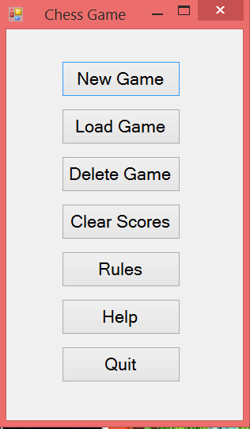

1. To start a new game, click the new game button and continue to the next form, alternatively, if you have a previously saved game, you can load it by clicking the “Load Game” button and selecting your game.
2. If you choose to start a new game, this form will pop up and you must enter the appropriate details. The name that you want to save the game as, your initials and your partners initials. The latter two of these must be in capitals.

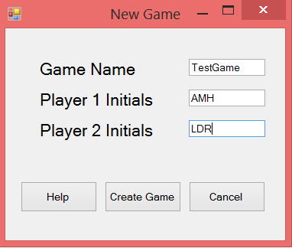

1. Click the “Create Game” button to continue to the main game form. The features of the game screen are detailed below

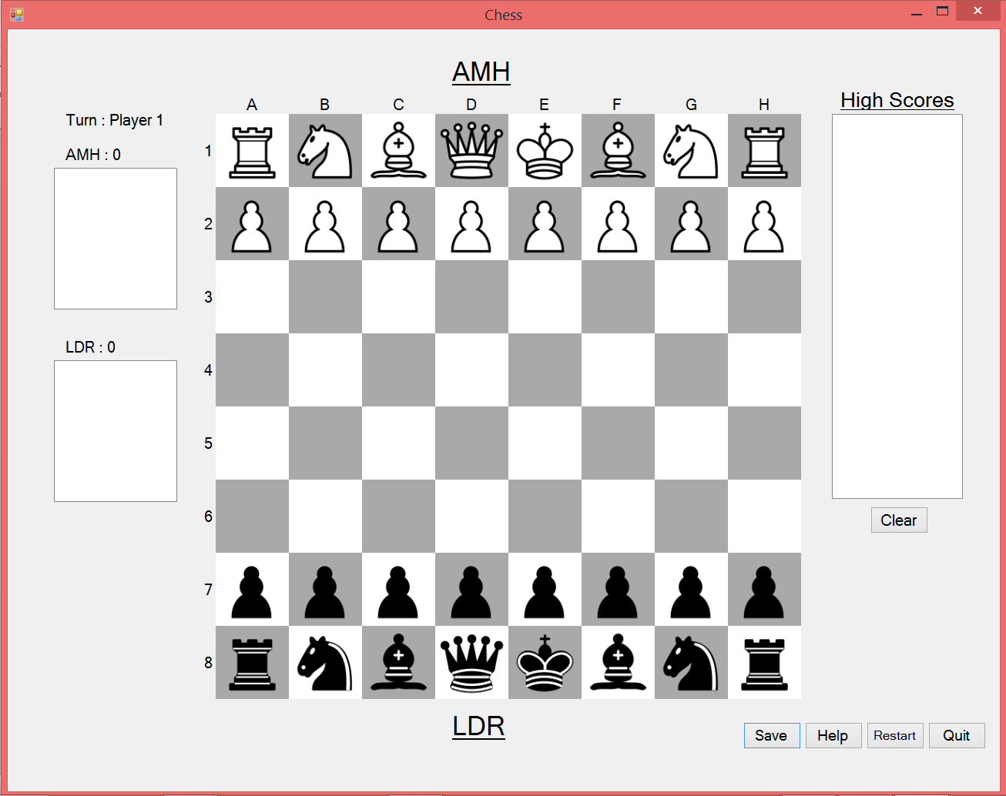

Pieces can be moved by clicking them once to view available moves, and then again to move to the desired square.

These boxes display lists of the pieces that have been lost by each player as well as the scores of each player

This box will display the scores of all previous players in descending order

These buttons allow you to save your game, restart it, quit it or access help.

Moves can be made by clicking on a desired piece. This will display all possible moves on the board by turning the tiles light blue. This when no tiles turn blue, this means that the piece has no available moves.   
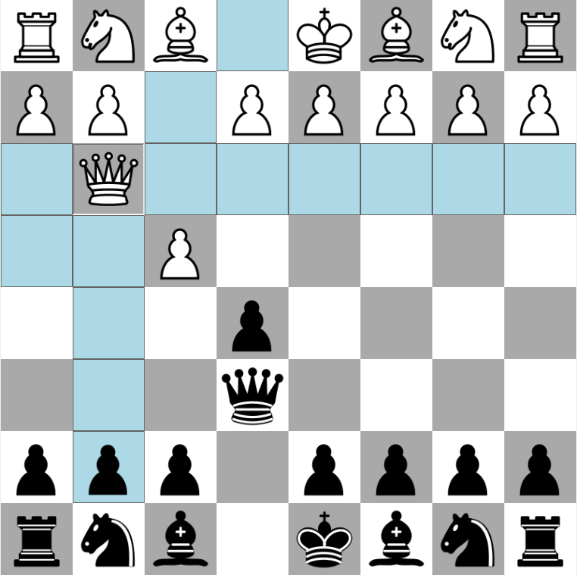

# Special Features

## Promotion

One of the rules of chess is that a prawn, upon reaching it’s opposite side, should be exchanged for a royal piece. This is done through the window below.

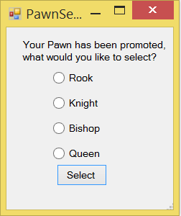

Check one of the radio buttons and then press select to change the piece

## Castling

One of the rules of chess is that the king and castle can undergo a special move called castling under the right circumstances. When a king is in a position to castle, the tile where it can move is shown highlighted red.

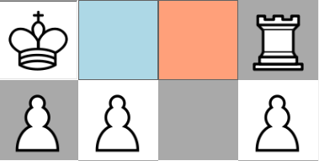

## Saving Games

You can save a game at any time to return to it, this is done by clicking the “Save” button on the game form. Games are also saved when someone wins.

## High Scores

The game stores the scores of all who have played it previously, these are displayed at the end of a game. To clear the high scores, there is a button on the main form called “Clear High Scores”. Once the high scores have been cleared, they cannot be regained.

# Hints and Tips

* Chess is an amazingly complex game and takes years of practice to master, so choose an opponent of your skill level.
* To win a game, you must actually take your opponents king instead of just put him into check mate.
* A help file can be reached at any time through the F1 key.
* A game tutorial can be reached through the help button on the main menu

# Trouble Shooting Guide

|  |  |  |
| --- | --- | --- |
| Problem | Cause | Solution |
| The turn counter does increments incorrectly | The turn counter is based upon an original player being player 1. This can be incorrect when a new game is loaded | Restart the game and make sure that the turn label is set to the name of the first player |
| My name keeps getting rejected when I enter it for a new game | The game only accepts initials that are at least 1 character long, and less than 6 characters long. They must be all capitals | Enter a set of initials that are between 1 and 5 characters long and all in capital letters. (no spaces) |
| One of my old games was erased when I created a new game | When you create a new game, you can erase an older game by giving your game the same name as it. This wipes over the older game. | Choose a new name for each game that you create |
| When I load a game, the grave is not in the same order as before | This is because the game cannot distinguish between the order of the grave | It is not really a problem because the order is only cosmetic |
| The game has crashed and a an error message has been displayed | Unknown | Restart the game with a new game. If error persists, contact technical support. |
| When I press F1, the resulting help file does not work | This is caused by the security settings of your computer and cannot be fixed without changing them | This cannot be fixed but the help file contains the same information as the user guide |

# Technical Support

For technical support, contact:

Andrew M Hall

Ph: (02) 64938444

Mob: 0402354771

Address: 55 Stonehaven Crescent, Deakin, Act